Report for Sorghum analysis

I. Samples
 | 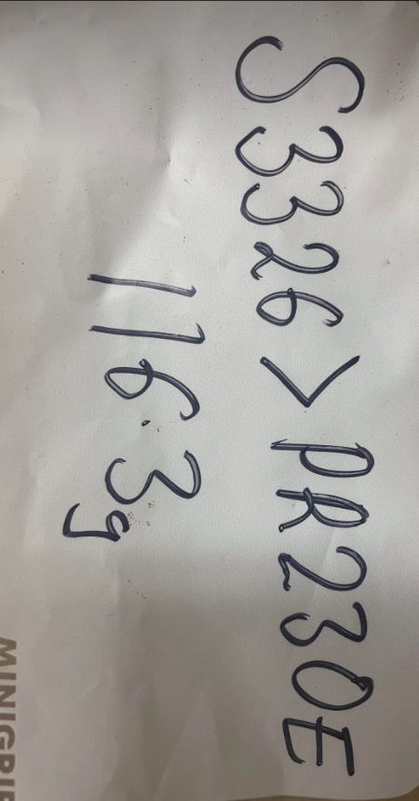
PI-586244-0 | S3326>PR230E
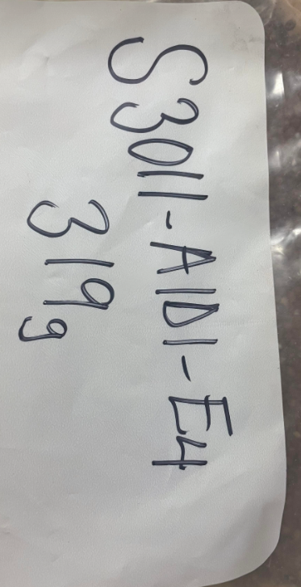 | 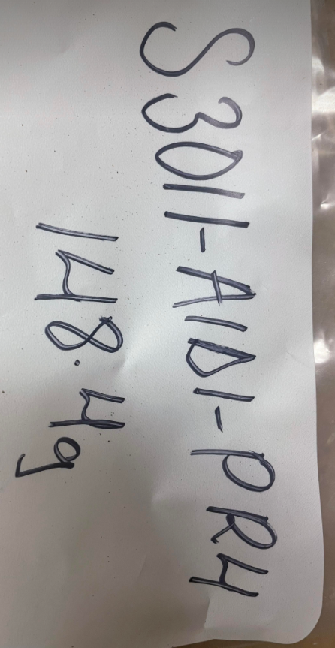
S3011-A1D1-E4 | S3011-A1D1-PR4

II. Analysis results
Table 1. Nutrient contents of sorghum samples
 |  | PI-586244-02 | S3326>PR230E | S3011-A1D1-E4 | S3011-A1D1-PR4 | P-value
Nutrients | units
Dry matter | % | 75.513 ± 0.187^{b} | 89.673 ± 0.071ª | 89.153 ± 0.489ª | 89.567 ± 0.065ª | <0.001
Moisture | % | 24.487 ± 0.187^{b} | 10.327 ± 0.071^{b} | 10.847 ± 0.489^{b} | 10.433 ± 0.065^{b} | <0.001
Crude protein | %, DM | 9.375 ± 0.165^{c} | 12.813 ± 0.108^{b} | 13.750 ± 0.348ª | 14.229 ± 0.253ª | <0.001
Total N | %, DM | 1.500 ± 0.026^{c} | 2.050 ± 0.017^{b} | 2.200 ± 0.056ª | 2.277 ± 0.040ª | <0.001
Fat | %, DM | 2.097 ± 0.127^{b} | 3.533 ± 0.176ª | 3.717 ± 0.176ª | 3.537 ± 0.023ª | <0.001
Crude fiber | %, DM | 2.203 ± 0.124^{d} | 4.863 ± 0.067a | 3.463 ± 0.081^{c} | 4.370 ± 0.053^{b} | <0.001
Gross energy | Kcal/kg, DM | 4368 ± 25^{b} | 4780 ± 18ª | 4744 ± 17ª | 4769 ± 10ª | <0.001
Data expressed as mean ± standard deviation (n = 3)
^{ad} means within the same row with different superscripts differ significantly (P < 0.05).

Table 2. Amino acid profile (%, DM) of sorghum samples
 | PI-586244-02 | S3326>PR230E |  | S3011-A1D1-E4 |  | S3011-A1D1-PR4 |  | P-value
Essential amino acids
Arginine | 0.393 ± 0.008^{c} | 0.487 ± 0.006^{b} |  | 0.490 ± 0.013^{ab} |  | 0.514 ± 0.011ª |  | <0.001
Histidine | 0.309 ± 0.008^{c} | 0.335 ± 0.011^{b} |  | 0.340 ± 0.013^{b} |  | 0.368 ± 0.000ª |  | <0.001
Isoleucine | 0.614 ± 0.008^{b} | 0.699 ± 0.034ª |  | 0.718 ± 0.022ª |  | 0.737 ± 0.011ª |  | 0.001
Leucine | 1.854 ± 0.026^{b} | 2.316 ± 0.134ª |  | 2.326 ± 0.086ª |  | 2.475 ± 0.039ª |  | <0.001
Lysine | 0.313 ± 0.008ª | 0.290 ± 0.011^{b} |  | 0.295 ± 0.006^{ab} |  | 0.305 ± 0.006^{ab} |  | 0.032
Methionine | 0.212 ± 0.000^{b} | 0.260 ± 0.017ª |  | 0.254 ± 0.006ª |  | 0.268 ± 0.011ª |  | 0.001
Phenylalanine | 0.746 ± 0.008^{b} | 0.855 ± 0.045ª |  | 0.879 ± 0.034 |  | 0.927 ± 0.011ª |  | <0.001
Threonine | 0.424 ± 0.000^{c} | 0.461 ± 0.017^{b} |  | 0.464 ± 0.013^{ab} |  | 0.495 ± 0.013ª |  | 0.001
Tryptophan | 0.119 ± 0.000^{b} | 0.130 ± 0.006^{b} |  | 0.146 ± 0.000ª |  | 0.149 ± 0.006ª |  | <0.001
Valine | 0.711 ± 0.008^{b} | 0.822 ± 0.034ª |  | 0.830 ± 0.019ª |  | 0.860 ± 0.011ª |  | <0.001
Non-essential amino acids
Alanine | 1.315 ± 0.040^{b} | 1.565 ± 0.078ª |  | 1.555 ± 0.055ª |  | 1.678 ± 0.034ª |  | <0.001
Aspartic Acid | 0.861 ± 0.000^{c} | 1.019 ± 0.028^{b} |  | 1.036 ± 0.032^{b} |  | 1.109 ± 0.013ª |  | <0.001
Cysteine | 0.234 ± 0.008^{b} | 0.260 ± 0.017^{ab} |  | 0.254 ± 0.006^{ab} |  | 0.268 ± 0.011ª |  | 0.032
Glutamic Acid | 2.869 ± 0.047^{b} | 3.542 ± 0.190ª |  | 3.537 ± 0.140ª |  | 3.766 ± 0.090ª |  | <0.001
Glycine | 0.402 ± 0.008^{c} | 0.413 ± 0.000^{bc} |  | 0.422 ± 0.013^{ab} |  | 0.435 ± 0.000ª |  | 0.003
Hydroxylysine | 0.088 ± 0.020^{b} | 0.022 ± 0.000a |  | 0.022 ± 0.000ª |  | 0.033 ± 0.000ª |  | <0.001
Hydroxyproline | 0.022 ± 0.008 | 0.019 ± 0.006 |  | 0.015 ± 0.006 |  | 0.011 ± 0.000 |  | 0.214
Ornithine | 0.049 ± 0.008^{b} | 0.004 ± 0.006ª |  | 0.011 ± 0.000ª |  | 0.007 ± 0.006ª |  | <0.001
Proline | 1.086 ± 0.023^{c} | 1.286 ± 0.061^{b} |  | 1.305 ± 0.034^{ab} |  | 1.399 ± 0.034ª |  | <0.001
Serine | 0.547 ± 0.008^{b} | 0.610 ± 0.017ª |  | 0.606 ± 0.022^{ab} |  | 0.666 ± 0.036ª |  | 0.002
Taurine | 0.159 ± 0.000ª | 0.152 ± 0.006^{ab} |  | 0.150 ± 0.006^{ab} |  | 0.145 ± 0.000^{b} |  | 0.034
Tyrosine | 0.424 ± 0.023 | 0.446 ± 0.019 |  | 0.430 ± 0.039 |  | 0.480 ± 0.011 |  | 0.097
Data expressed as mean ± standard deviation (n = 3)
^{ac} means within the same row with different superscripts differ significantly (P < 0.05).

Table 3. Mineral contents of Sorghum samples
 |  | PI-586244-02 | S3326>PR230E | S3011-A1D1-E4 | S3011-A1D1-PR4 | P-value
Minerals | units
Ca | %, DM | 0.026 ± 0.014 | 0.026 ± 0.002 | 0.018 ± 0.002 | 0.023 ± 0.002 | 0.627
P | %, DM | 0.334 ± 0.010^{c} | 0.384 ± 0.002^{b} | 0.369 ± 0.007^{b} | 0.421 ± 0.009ª | <0.001
IP6 | mg/g, DM | 0.228 ± 0.019^{c} | 1.564 ± 0.079^{b} | 1.632 ± 0.039^{b} | 1.932 ± 0.141ª | <0.001
K | %, DM | 0.344 ± 0.006ª | 0.293 ± 0.001^{b} | 0.304 ± 0.012^{b} | 0.350 ± 0.009ª | <0.001
Mg | %, DM | 0.132 ± 0.009^{b} | 0.187 ± 0.003ª | 0.171 ± 0.002ª | 0.186 ± 0.006ª | <0.001
S | %, DM | 0.008 ± 0.002 | 0.010 ± 0.001 | 0.009 ± 0.002 | 0.011 ± 0.002 | 0.165
Mn | ppm, DM | 16.502 ± 1.628^{c} | 28.234 ± 0.413ª | 21.821 ± 0.145^{b} | 27.745 ± 0.640ª | <0.001
Fe | ppm, DM | 40.895 ± 8.354 | 39.304 ± 0.369 | 45.090 ± 7.311 | 38.034 ± 1.251 | 0.481
Cu | ppm, DM | 7.021 ± 1.290 | 6.166 ± 0.433 | 6.321 ± 0.291 | 8.600 ± 2.639 | 0.271
Zn | ppm, DM | 20.902 ± 2.067^{c} | 29.215 ± 0.525ª | 25.642 ± 0.155^{b} | 31.697 ± 0.634ª | <0.001
Na | ppm, DM | 246.243 ± 42.658ª | 158.347 ± 21.191^{b} | 155.693 ± 15.055^{b} | 151.181 ± 30.206^{b} | 0.021
Data expressed as mean ± standard deviation (n = 3)
^{ac} means within the same row with different superscripts differ significantly (P < 0.05).

